APPLICATION for 2015 Mary Frierson SCHOLARSHIP
Sponsored by the Fort Bend Branch of
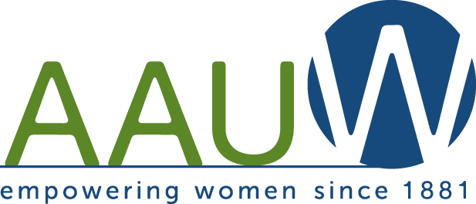

ABOUT US
The mission of American Association of University Women is to advance equity for women and girls through advocacy, education, philanthropy, and research. This $750 scholarship is in memory of long-time branch member Mary Frierson.

CRITERIA
Applicant must answer “YES” to all of the following questions:
Criteria | YES | NO
Are you a United States citizen?
Are you a female and a resident of Fort Bend County?
Are you currently enrolled at WCJC?
At the beginning of the current semester, had you completed at least 24 hours of college credit?
Do you have a GPA of 2.5 or above?
Are you pursuing either an associate or bachelor’s degree?
Have you enclosed your WCJC transcript?

QUESTIONS?
Please direct questions to jccenkus@aol.com.

APPLICANT
Name: _______________________________________________________________________________
Address: ______________________________________________________________________________
Phone: _____________________________________ E-mail: ___________________________________

Please attach an additional page describing your plans for your future. What degree are you pursuing? Why? Overcome any obstacles? How do you plan to use your education? (Minimum 200 words.)

Submit this form with your transcript to:
AAUW Scholarship, 6810 Chessley Chase Dr, Sugar Land, TX 77479

DEADLINE: MARCH 1, 2015

