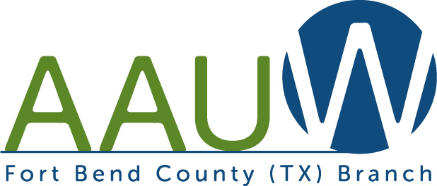

Welcome to the American Association of University Women!
Our mission is to advance gender equity for women and girls through research, education, and advocacy.

We are thrilled to have you join our branch!
Name: ________________________________________
E-mail address: _________________________________
Phone number: _________________________________
Address: _______________________________________________________________
Postsecondary School: __________________________________ Major___________
Please write your check to Fort Bend County AAUW and either give it to Finance Chair Margo Johnson in person or mail it to her at 3314 Palm Desert Lane, Missouri City, TX 77459. For 2018-19 dues are $85 (includes national, state, and local). Please enclose this form too!

Here is what we are proud of: